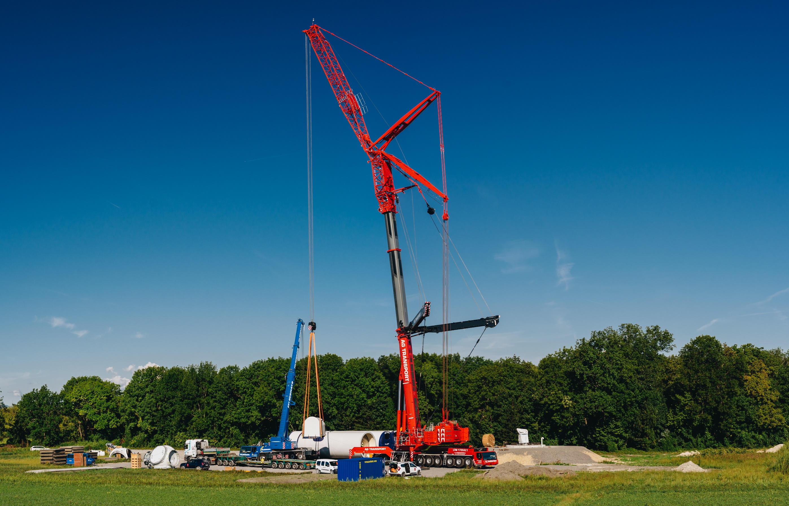


Diversity and Inclusion Policy

January 15, 2021

AG TRANSPORT, s.r.o.
Průmyslová 1141,
686 01 Uherské Hradiště
Czech Republic

AG TRANSPORT is committed to creating an inclusive culture amongst its entire workforce and business partners as it strongly believes that promoting a balanced, discrimination free, diverse workforce is in the interest of the business’ future success.

Our Commitment

AG TRANSPORT´s aim is to ensure that all employees, business partners (contractors, suppliers and customers) and job applicants are given an equal opportunity to work with us or for us and that our organization represents the communities in which we are located.
This policy reinforces our commitment to providing equality and fairness to all employees, job applicants and business partners and not providing less favorable treatment on the grounds of age, disability, gender, marriage and civil partnership, pregnancy and maternity, race, ethnic origin, color, nationality, national origin, religion or belief gender reassignment, or sex and sexual orientation. We are opposed to all forms of unlawful and unfair discrimination.

Targets

AG TRANSPORT is committed to ensuring that all employees are given help and encouragement to develop their full potential and utilize their unique talents. We are committed to:
- Maintaining a working environment that promotes dignity and respect for every employee and ensuring that all employees are treated with dignity and respect.
- Maintaining an environment in which differences are recognized and valued.
- Enduring that training and development is available to 100% of employees.
- Advocating equality in the workplace, which AG TRANSPORT believes od good management practice and makes sound business sense.
- Not tolerating any form of intimidation, bullying, or harassment.
- Encouraging employees who feel they have been subject to discrimination or harassment to raise their concerns (in confidence if appropriate) via practices and procedures so that fairness is always maintained AG TRANSPORT´s existing communication channels.
- Regularly reviewing all of our employment.
- Ensure that from 2022 onwards 100% of employees are aware of AG TRANSPORT´s Diversity & Inclusion Policy.

Scope of Application

This policy applies to all employees working with the AG TRANSPORT, candidates applying for a position in the Company and business partners cooperating with the AG TRANSPORT.

Review Mechanism

AG TRANSPORT reviews thus Diversity and Inclusion Policy, as part of its Sustainability Committee agenda, on an annual basis. This includes reviewing the implementation and effectiveness of the policy and, where necessary, making amendments.

Roles and Responsibilities

This policy is publicly available for all to view and read and expresses our approach explicitly and transparently. It is of particular importance and relevance to AG TRANSPORT´s employees and business partner (contractors, suppliers and customers). This policy is fully supported by senior management of AG TRANSPORT. In the interests of clarity and to highlight the importance AG TRANSPORT puts on Diversity and Inclusion, the Chief Executive of AG TRANSPORT has been appointed to company’s Chief Officer of this matter.
Each and every employee is not only aware of diversity and inclusion policy, but also is obligated to comply with its requirements. Our employees are required, where appropriate, to participate in training courses on this subject and report any inconsistencies through our Speak-UP system.

Sanctions

15.01.2021  Uherské Hradiště, CZ | 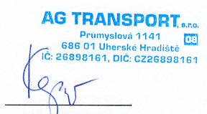  Mgr. Tomáš Kepič  managing director
Where targets are not met, or where there are breaches in compliance, investigations will take place to establish the root cause, and suitable remedial actions with appropriate timescales will be implemented.

